Activity assessed
Contract name
Contract address
Contract start date
Assessment completed by |  | Assessor’s signature
Risk assessment date |  | Next review date

Groups affected (mark as appropriate)
  Staff |   Subcontractors |  |   Other Contractors |   The Public |   Customers |   Young worker | Others (please specify)
 |  |  |  |  |  |  |  | Risk Ranking (see key)
Hazard identified |  | Control measures to reduce risk |  |  |  |  |  | L | I | RR

PPE requirements (mark as appropriate)
  Helmet |   Ear defenders |   Footwear |   Gloves |   Googles |   Overalls |   Respiratory |   Harness |   Face protection
Others (please specify)

Additional Comments
Risk Ranking Key
Impact (I)
 |  | 1 - Slight | 2 -Small | 3 -Moderate | 4 - Significant | 5 - Severe |  | Risk Ranking Key
Likelihood (L) | 5 – Certain | 5 | 10 | 15 | 20 | 25 |  | 1 – 4 Low
 | 4 - Highly Likely | 4 | 8 | 12 | 16 | 20 |  | 5 – 9 Low Medium
 | 3 – Likely | 3 | 6 | 9 | 12 | 15 |  | 10 – 14 Medium
 | 2 – Unlikely | 2 | 4 | 6 | 8 | 10 |  | 15 – 19 Medium High
 | 1 - Highly Unlikely | 1 | 2 | 3 | 4 | 5 |  | 20 – 25 High

Sign off sheet

I have read and understood the entirety of this document. Where there was something, I did not fully understand, it was explained to my satisfaction. I agree to comply with the required directions and instructions in this document. If at any point, I cannot comply I will highlight this to my superior before continuing.

Name | Signature | Date
Important information – PLEASE READ BEFORE SUBMITTING

The following page should be removed before any submissions to third parties as it acts as instructions for use and further information intended for you.
The above template has been created for you to use and apply to your tasks and situations. Before use, you should ensure that a competent individual has adequately assessed any additional risks which may be present during your works.
As a best practice, a safe system of work (or method statement) for the task assessed should also be produced highlighting a systematic approach to how the work will be done safely.
Should the task assessed involve any substances deemed hazardous to health, a relevant COSHH assessment should be produced highlighting specific control measures for substances to be observed by affected parties.

Creating additional rows for additional hazards
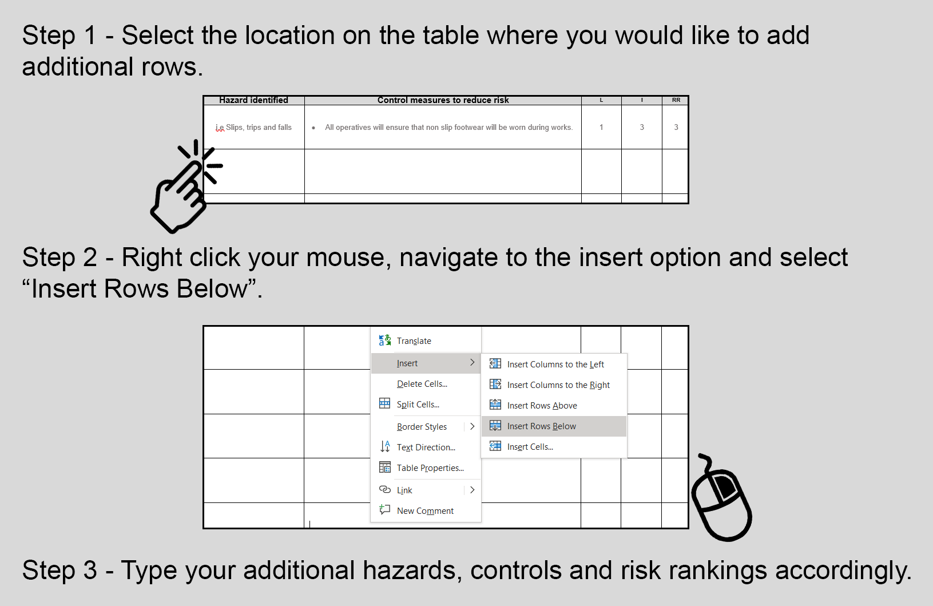

For additional assistance and further template documentation:
www.safetyplace.co.uk.

